**Test Case** **0051**

**System:** VirtuCardsHost and VirtuCardsClient

**Description:** [Create test cases that ensure songs are added to the queue when players add more songs.](https://github.com/VirtuCard/VirtuCard/issues/368)

**Severity:** 3

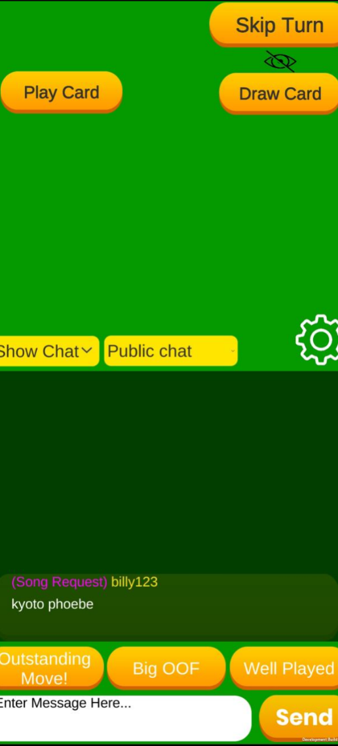Throughout the following test cases, the !play command is used. The usage is as shown below:

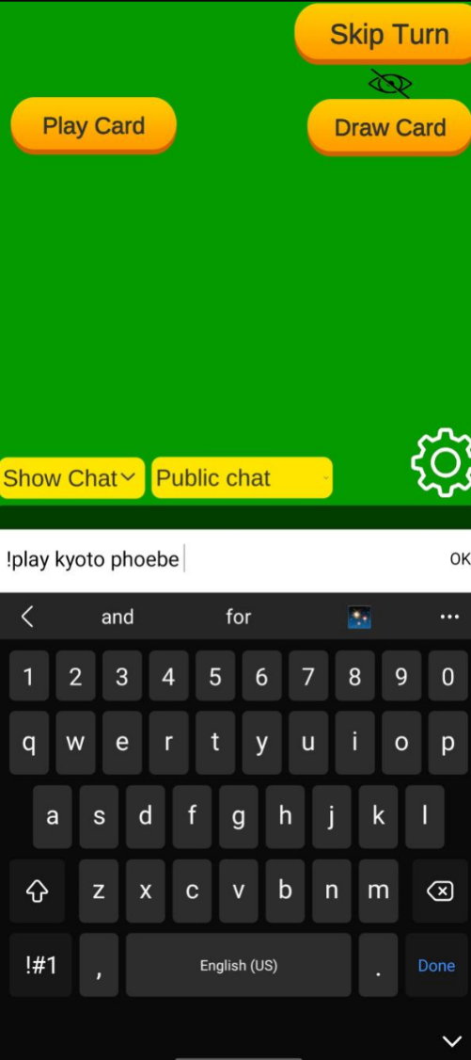

The result of the command is the input song name added to the Chat panel as a private message only visible to the user who sent it. It’s highlighted as a Song Request to distinguish these requests.

An example usage of the !play command, used in the chat during a game.

**Instructions**

**Test 1**

1. Start VirtuCardClient application
2. Click the button labeled “Sign In”
3. Enter “test@test0.com” into the text input labeled “Enter email…”
4. Enter “Password!123” into the text input labeled “Enter password…”
5. Press the button labeled “Login”
6. A window should appear saying “Login Success”
7. Press the OK button that appears on that window
8. Start VirtuCardsHost application
9. Choose a desired game mode
10. Click the Create Game button
11. Enter the displayed Join Room Code in the VirtuCardsClient application.
12. Press the Music button on the Host’s game screen.
13. In the chat on the VirtuCardsClient, type in ‘!play Numb Linkin Park’

**Expected Result:** The song Numb by Linkin Park should be added into the queue on the music panel on the host.

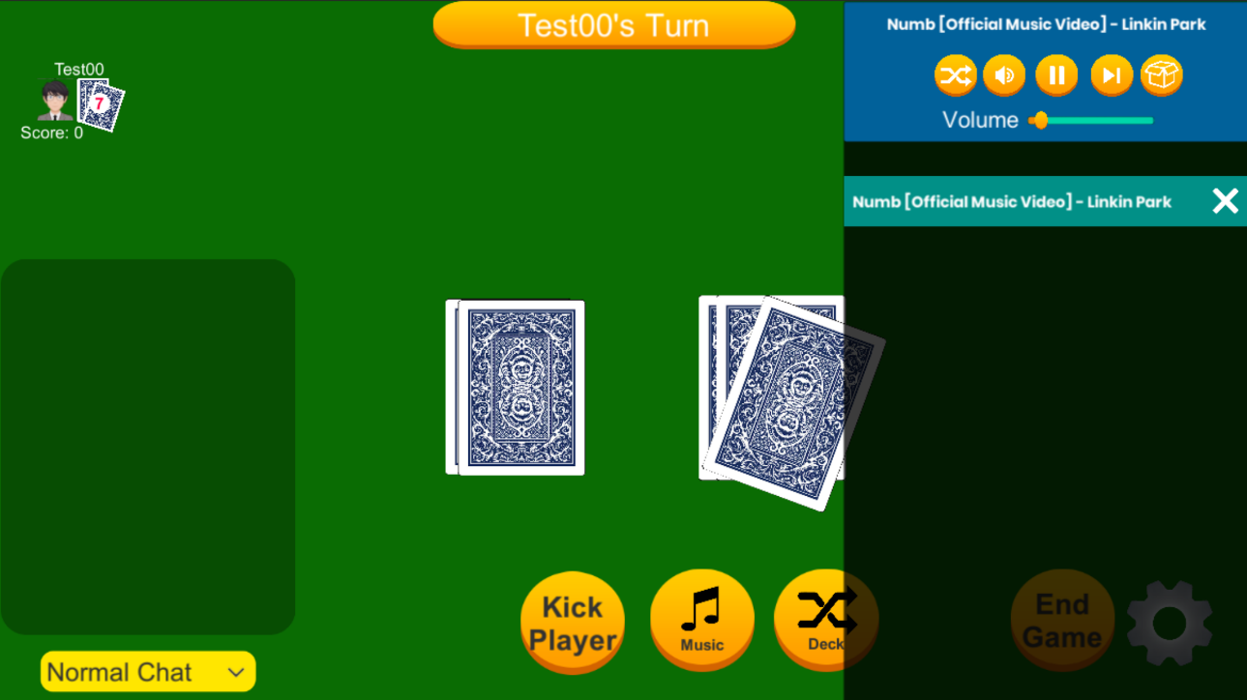

The song Numb by Linkin Park has been added to the music panel in the Game screen of the VirtuCardsHost

**Test 2**

1. Start VirtuCardClient application
2. Click the button labeled “Sign In”
3. Enter “test@test0.com” into the text input labeled “Enter email…”
4. Enter “Password!123” into the text input labeled “Enter password…”
5. Press the button labeled “Login”
6. A window should appear saying “Login Success”
7. Press the OK button that appears on that window
8. Start VirtuCardsHost application
9. Choose a desired game mode
10. Click the Create Game button
11. Enter the displayed Join Room Code in the VirtuCardsClient application.
12. Press the Music button on the Host’s game screen.
13. In the chat on the VirtuCardsClient, use the !play command to add multiple songs.

**Expected Result:** All the songs should be queued into the music panel on the VirtuCardsHost.

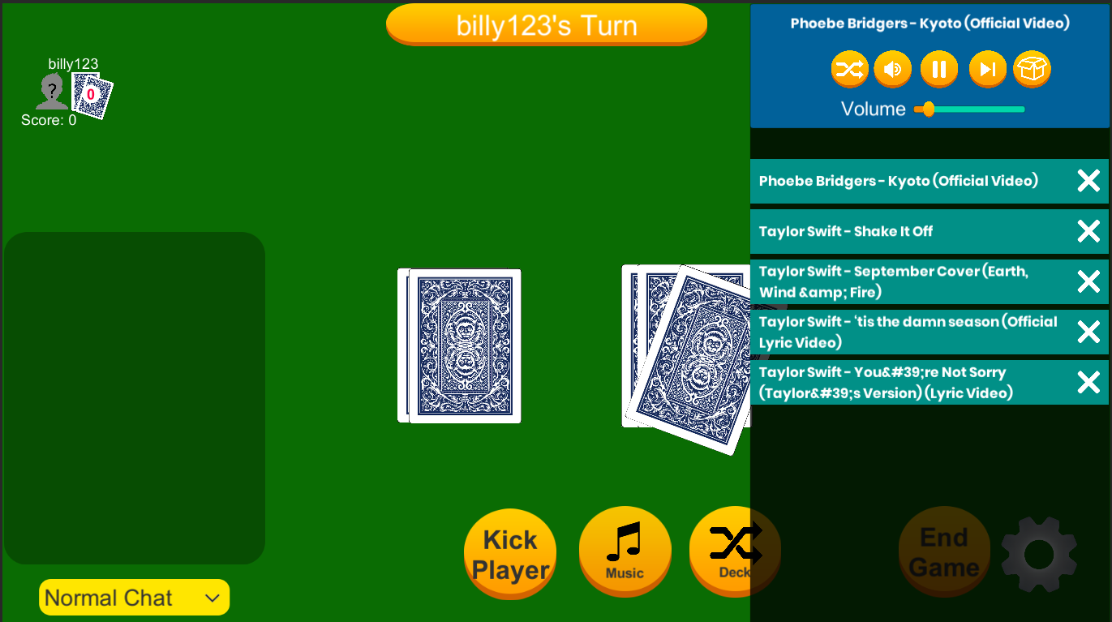

The songs have been added to the music panel in the VirtuCardsHost screen.

**Test 3**

1. Start VirtuCardClient application
2. Click the button labeled “Sign In”
3. Enter “test@test0.com” into the text input labeled “Enter email…”
4. Enter “Password!123” into the text input labeled “Enter password…”
5. Press the button labeled “Login”
6. A window should appear saying “Login Success”
7. Press the OK button that appears on that window
8. Start VirtuCardsHost application
9. Choose a desired game mode
10. Click the Create Game button
11. Enter the displayed Join Room Code in the VirtuCardsClient application.
12. Press the Music button on the Host’s game screen.
13. In the chat on the VirtuCardsClient, use the !play command to add multiple songs.
14. Press the Shuffle button indicated by the crossed arrows button.

**Expected Result:** The queue should be shuffled with the songs being played in a random different order as before. The song now at the top of the queue should be playing.

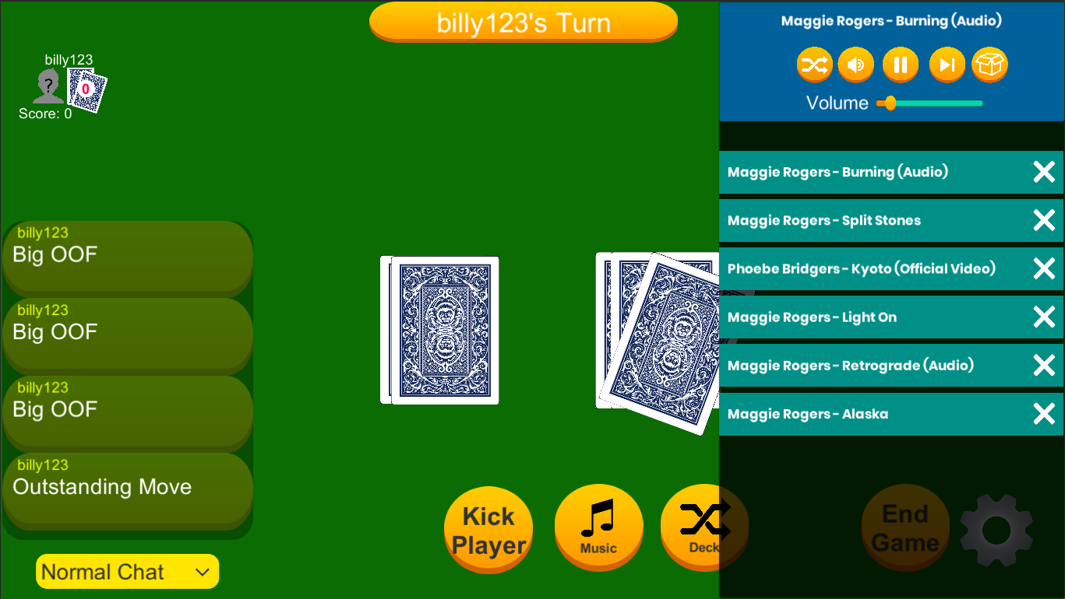**Test 4**

The order of the songs in the queue has been shuffled and this has been indicated by the new order in the panel. Additionally, the old song has stopped and the new first song has started playing.

1. Start VirtuCardClient application
2. Click the button labeled “Sign In”
3. Enter “test@test0.com” into the text input labeled “Enter email…”
4. Enter “Password!123” into the text input labeled “Enter password…”
5. Press the button labeled “Login”
6. A window should appear saying “Login Success”
7. Press the OK button that appears on that window
8. Start VirtuCardsHost application
9. Choose a desired game mode
10. Click the Create Game button
11. Enter the displayed Join Room Code in the VirtuCardsClient application.
12. Press the Music button on the Host’s game screen.
13. In the chat on the VirtuCardsClient, use the !play command to add multiple songs.
14. Press the Mute button indicated by the button with a loudspeaker icon.

**Expected Result:** The songs should continue playing on mute and the queue should keep updating accordingly.



The game screen when the music queue is being played on mute.